SESSION 8 — Gearhaven
Beat 4 — The Underworks (Fight 2)

The Descent
The freight-lift is a rusted iron cage marked A12, barely big enough for the four of you and the great chain that lowers it. Vane throws the lever, and with a clank-clank-CLANK the cage drops into the dark.
Down you go. The warm golden light of Gearhaven shrinks to a glowing coin high above your heads. Below and all around unfolds the Underworks — a cathedral of pipes, gears the size of houses, catwalks, and sleeping machines, lit by drifting steam and the faint, sick blue glow of something far below.
The air turns cold and wet and smells of oil and old copper. Ghostbloom drifts close, its teal glow lighting the cage — and then, the deeper you go, its light begins to flutter, like a candle in a draft. It presses against your shoulders and makes a small, worried sound.
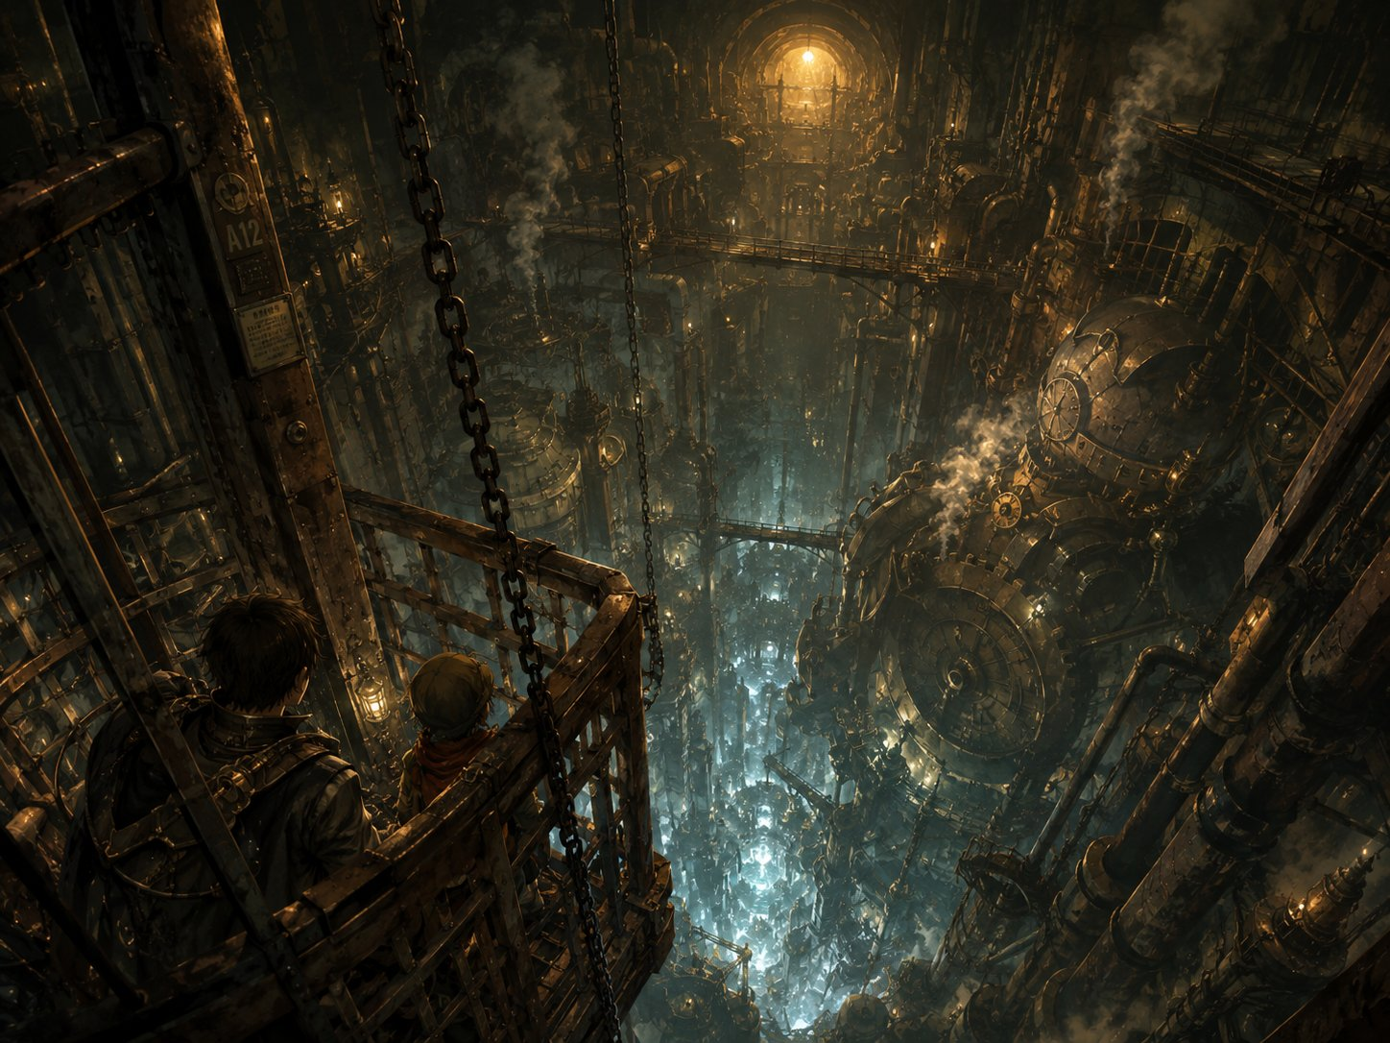
Down into the Underworks — the warm city shrinking to a coin of light above.
▶ Setting the tone. Let the descent breathe before anything happens. Ghostbloom’s guttering glow is the first sign something is wrong down here — a fey creature reacting to the nearness of the crack. Play it nervous.
Lilly: “My Sphere’s humming. It does that when there’s loose magic around — a lot of it. Down there.”
Ursa: “Ghostbloom doesn’t like it. Neither do I — there’s nothing alive down here. No birds, no roots, no sky. Just metal that goes down forever.”
Stabby: “Ooh, creepy. I LOVE it. …Hey. Why’s my idol cold? It’s never cold.”

The Rift Hall
The cage clanks to a stop and you step out onto a broad iron walkway — and stop dead.
The whole far end of the hall is gone.
Where the wall should be, there’s a rift — a colossal tear in the world itself, four stories tall, its edges crackling with chains of blue-white lightning. And through the gap you can see another place: a churning sky of purple and rose clouds, broken towers and clockwork spires floating in nothing, a sun setting over an ocean that hangs sideways. It’s beautiful. It’s wrong. It hums in your teeth.
Lilly steps to the railing before any of you, staring up at it, the light painting her face blue. Her Sphere is yanking in her pack toward the tear.
Behind you, Ghostbloom shrinks small, its glow nearly out. And in Stabby’s pocket, the little idol goes ice cold — colder than the cavern, cold enough to ache — and for one heartbeat it seems to pull him toward the rift.
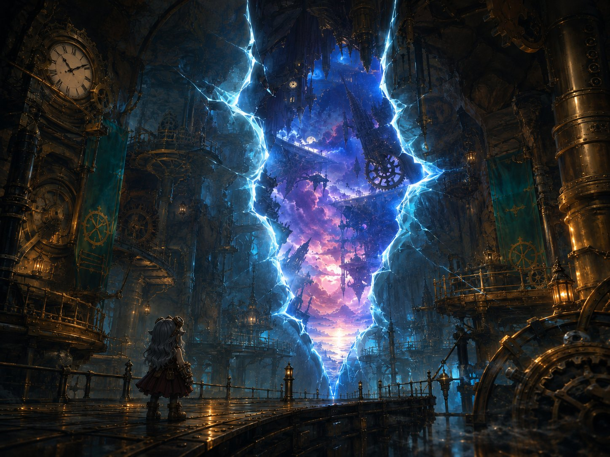
Lilly faces the rift — a tear in the world, and another sky beyond it.
▶ Lilly’s moment (give her the foreground). She’s the artificer; she knows what this is, and it’s far bigger than the “go fetch aether” errand Vane sent them on. This plants her sense that the real story is bigger than her job — seeding her time-skip paths (mote-research, and the larger pull to stay and understand the rift).
▶ Ursa’s seed (the quiet counter-note). Against Lilly’s fascination, Ursa is the one who can’t stand it — nothing living, his star-magic thin with no sky to draw on. Two reactions to the same wonder: Lilly drawn in, Ursa wanting out. This is his wilderness path, planted.
▶ Stabby’s seeds (idol + unfinished training). The idol goes cold — your recurring tell; it’ll stir again at the tremor and the boss. And the monk touch: the wrongness is exactly what Master Kaelon taught stillness for. Stabby reaches for that calm center and can’t find it.
Lilly: “It’s a planar rift. A real one. My mom told me stories — she said you could go your whole life and never see one. We’re not collecting spare parts down here, are we? This is… this is the whole thing. This is what’s wrong.”
Ursa: “I can barely feel the stars this deep. No sky to pull from — just rock pressing down. I don’t think I’m meant to be underground this long, Lilly.”
Stabby: “Master Kaelon always said — somethin’s wrong, get still, find your center. I’m tryin’. I’m tryin’ real hard. …It ain’t workin’.”
Ghostbloom (DM): “Cold. Cold and empty. That tear should not be, little stars. Do not look too long. It looks back.”

The Swarm — Fight 2 Begins
A voice cracks across the hall — high, panicked, and familiar to one of you:
“H-HELP! Somebody! I’m stuck — they’re comin’ back — PLEASE—!”
Below the rift, half-crushed under a fallen pipe-assembly, is a goblin. Small, green, bleeding, one arm pinned. He’s reaching toward you with his free hand.
And then the rift flares — and they pour out of it.
Dog-sized things made of glitching blue-white light, like spiders crossed with lightning, sparking in and out of being as they scuttle down the walls and webbing. Electricity arcs between them. And behind them, hauling itself through the tear on eight crackling legs, trailing ropes of glowing planar silk — something huge.
Ghostbloom lets out a terrified wail. Then, shaking, it forces itself to blaze bright at your side anyway.
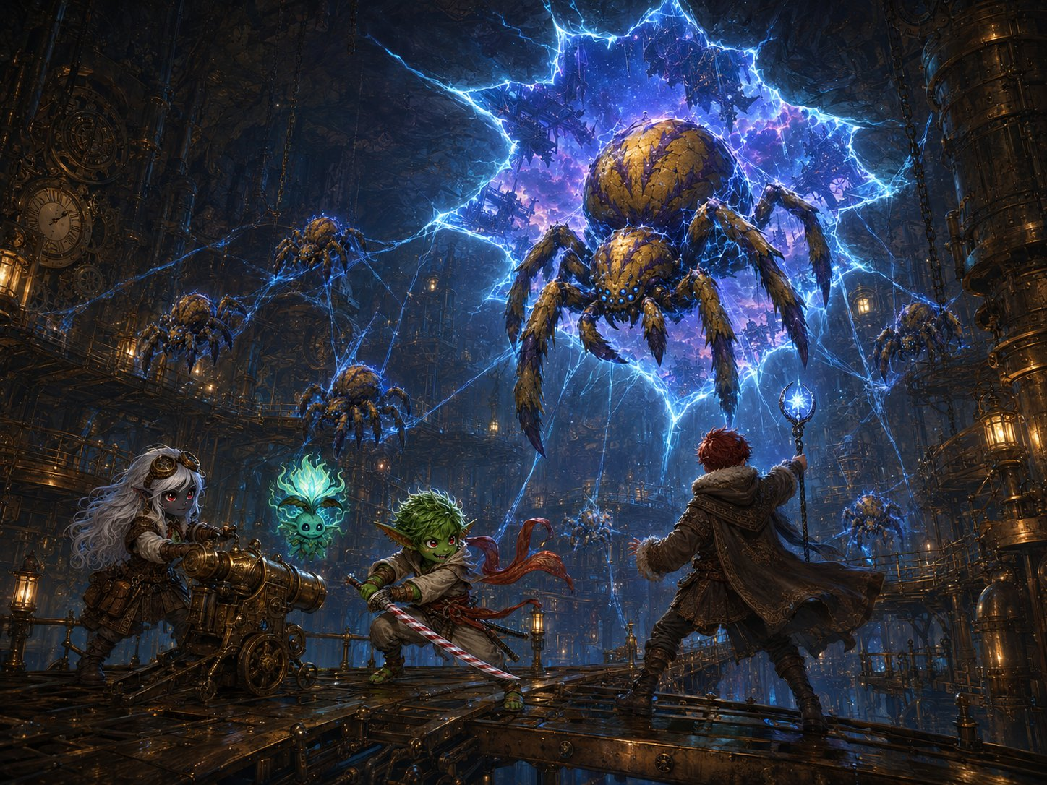
The swarm descends — Voltcrawlers and the Broodmother pour through the rift onto the catwalks.
▶ Roll initiative. Skitch’s death clock starts now: 3 rounds before he begins death saves. Plant a flicker of Stabby’s recognition this turn (“those markings—”) and let the full weight land in the breather once Skitch is safe.
Stabby (recognition flicker): “Those markings — that warpaint — that’s a Bloodfang. That’s one of mine! Hey! HEY! We’re comin’!”
Lilly: “Cannon — deploying! They blink in and out — don’t waste shots on empty air, hit ’em when they’re SOLID! Force and starlight punch through!”
Ursa: “Get to the goblin — I can save him! Just buy me the time!”

Running Fight 2 (HARD)
Battlefield. Skitch is the objective — pinned below the rift. Heroes must hold near him; leaving the spot undefended for more than one round means a Voltcrawler reaches him (auto-hit; pinned, he can’t dodge → immediate death saves). Catwalks are narrow (hard to fight more than two abreast; a fall is 20 ft, 2d6, into the dark).
The pressure. This is HARD on purpose for a min-maxed level-5 four. Saving Skitch pins them to a fixed spot, cancelling their kiting advantage. Lean on the Broodmother’s web (kills Stabby’s and Ursa’s mobility) and the Voltcrawlers’ lightning-clumping. A hero may drop — if one does, the choice of whether to spend a save on the hero or on Skitch IS the beat.
Ghostbloom in the fight. Run Guardian’s Light (1d8+3 heal, ends charm/fear, 3/short rest) as available but emotionally costly — it has to push toward the wrongness to help. Save it for a dropped hero, not to trivialize the fight. It clings near Ursa (the most “alive” of the three to a fey thing).
Rift Pulse (every round, initiative 20). The rift flares. Each creature within 20 ft makes a DC 13 Wis save or has disadvantage on its next attack. Ghostbloom auto-fails — narrate the flinch. This hits the Voltcrawlers too, giving a reason to fight away from the tear.
Scaling dials. Too easy: the Broodmother lays an egg-sac — two more Voltcrawlers hatch on round 3; chain more Arcs. Too hard / Skitch dying for real: a Voltcrawler “phases wrong” and is stuck Unreal a round (one fewer attacker), or Ghostbloom finds its courage early and burns Guardian’s Light on Skitch.
Mote drop (Lilly’s seed). A slain Voltcrawler doesn’t leave a body — it collapses into a single hanging mote. Lilly can grab them (free interaction / a satisfying snatch). The Essence Sphere lunges toward each mote like a magnet, tugging in her pack. She isn’t gathering aether for Vane abstractly anymore — she’s carrying something that wants these motes. Plant the question; don’t answer it.

Saving Skitch — Ursa’s Spotlight
Read when a hero reaches Skitch / Ursa heals him.
Up close, the pinned goblin is in bad shape. But the moment golden healing light pours from Ursa’s hand and washes over him, his eyes flutter open. He gasps, coughs — and stares up at the auburn-haired druid kneeling over him.
“You… you healed me? But you’re surface-folk — you’re not even—” His eyes go wide as he takes in the rest of you. They land on Stabby — on the candy-cane katana, on the way he moves — and his jaw drops.
“…Sharpblade? Stabby Sharpblade? By the Hollow — it’s you.”
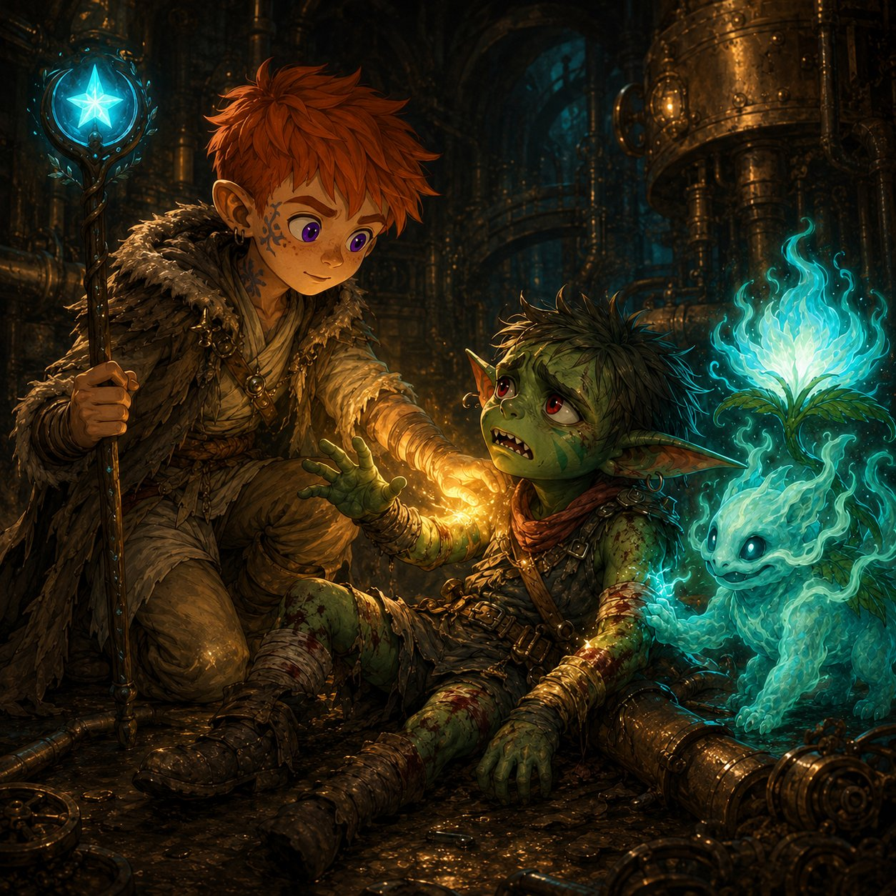
Ursa heals Skitch — a life saved with a single word.
▶ The pivot from combat to heart. Make sure Ursa gets the credit — he saved a life with a word. Then hand the moment to Stabby. Don’t rush it. If the kids want to question Skitch, let them — he’s grateful, overwhelmed, and will tell them everything.
Ursa: “Easy. You’re safe now. I’ve got you — you’re going to be okay.”
Stabby: “Skitch? Little Skitch, the courier? You got big. …What’re you doin’ all the way down here, so far from the Hollow?”

The Bloodfang Plea — Stabby’s Door
Skitch grabs Stabby’s sleeve with his good hand, words tumbling out:
“The Hollow’s in trouble, Stabby. Real trouble. Creatures like those —” he points at the last fading motes — “they’ve been comin’ through cracks near Bloodthorn for months. Monsters nobody’s ever seen. The clan’s scared. Half want to run, half want to fight — and a lot of ’em are sayin’ it’s the surface-folk doin’ it. The artificers, with their machines, tearin’ holes in the world.”
He swallows hard.
“But you — you’ve been out here. You’ve seen things. You know stuff none of us do. Stabby… they need you. Come home. Tell ’em what you know — before the scared ones do somethin’ stupid and start a war we can’t win.”
He looks up at all of you, pleading. Ghostbloom, braver now, settles its warm glow over his wounds and looks at Stabby with big, knowing eyes.
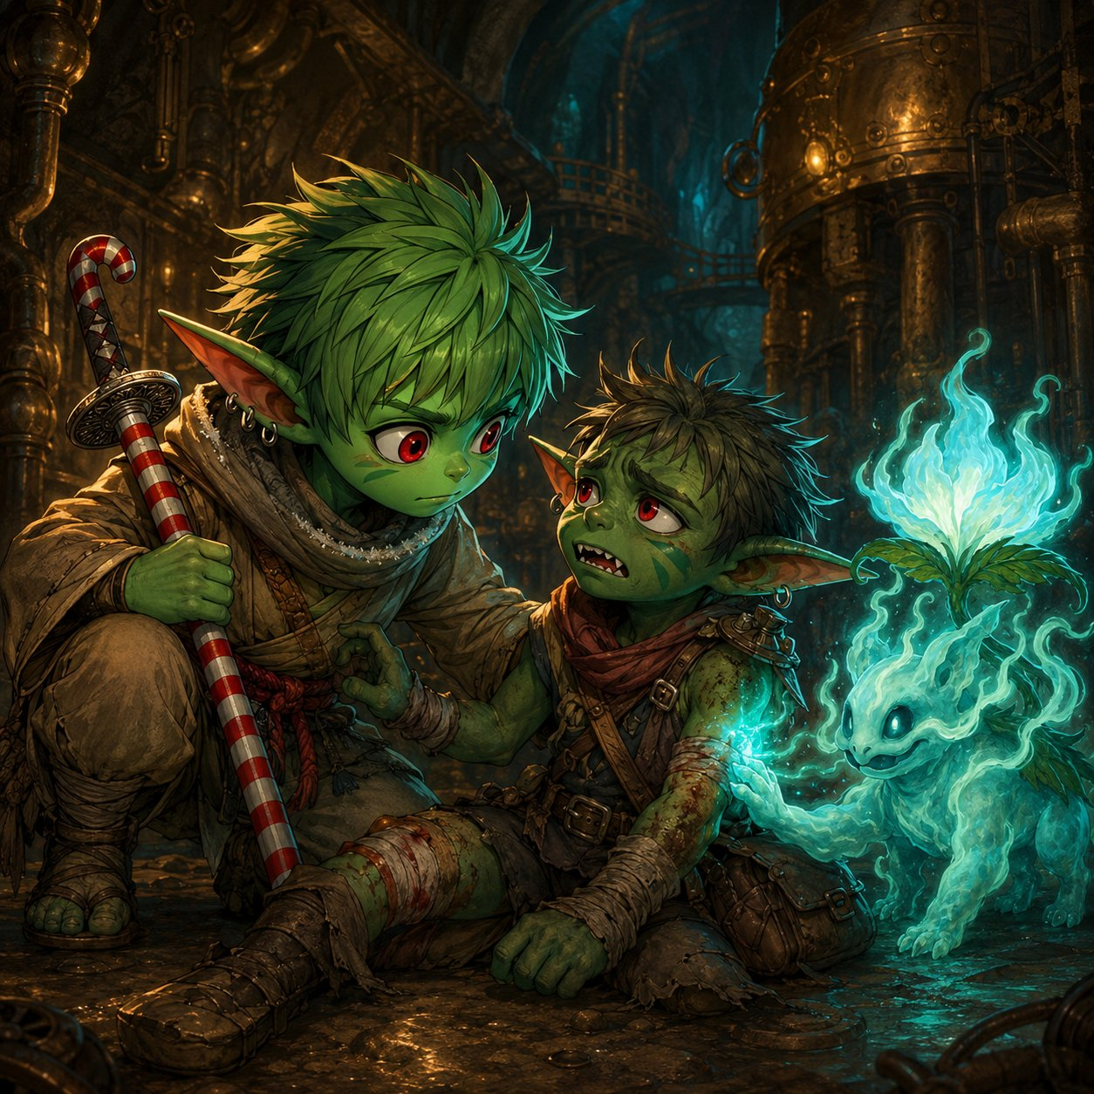
Skitch’s plea — a piece of home, bleeding under a machine, asking Stabby to come back.
▶ The Bloodfang seed — and it’s Stabby’s choice, not an obligation. Skitch isn’t summoning or demanding — he’s asking. The gremlin who chose to leave is looking at what leaving cost: a scared kid from home, a clan splintering, blame aimed at his own friends (the artificers — Lilly’s whole people). Don’t resolve it. Let it sit. He walks through the door (or doesn’t) in Beat 7.
Let the kid pick a feeling (offer these).
Stabby (brave): “…Maybe I will. But not yet — my crew needs me first.”
Stabby (deflecting): “Ha! Me, givin’ a speech to the clan? They’d throw rocks at me.” (…and the grin doesn’t quite hold.)
Stabby (quiet/honest): “I left ’cause I wanted somethin’ bigger. I didn’t think they’d ever need me.”
Lilly (the blame lands on her people): “They think the artificers are doing this? My people? We’re not tearing holes in the world — we’re trying to fix them. …Aren’t we?”

Hook — Into Beat 5
Skitch can stand now, leaning on Stabby. As you help him toward the lift, the whole hall lurches.
A deep, grinding BOOM rolls up from somewhere even deeper — and the rift flares, blinding-bright, spitting sparks across the ceiling. Catwalks shudder. Pipes burst. And from far above, down the shaft you climbed, you hear it:
Bells. Alarm bells. And screaming.
Ghostbloom snaps upright, its glow flashing red-tinged for the first time you’ve ever seen. Lilly’s Sphere is yanking straight up now — toward the city.
Skitch goes pale. “That came from Gearhaven. From up top. Whatever’s happenin’ down here…”
“…it’s happenin’ up there too. And there’s a lot more people up there.”
End of Beat 4. Next: up the shaft to the surface, where the planar surge erupts the city’s clockwork — Beat 5, The Tremor (Fight 3): a crowd-control swarm protecting civilians, Lilly’s diagnose-and-fix spotlight, and Vane’s “stay” offer. End the beat on the bells. (Enemy stats on the following page.)
Seed check. Lilly: rift-awe + mote-research ✓. Ursa: wilderness ✓. Stabby: Bloodfang ✓, idol ✓, unfinished monk training ✓. Ghostbloom woven throughout — guttering in the descent, frightened-then-brave in the fight, soothing in the breather, alarmed at the hook.

ENEMIES — Fight 2: The Underworks Swarm
The Underworks • Difficulty: Hard • 6× Voltcrawler + 1× Voltcrawler Broodmother
VOLTCRAWLER  Small aberration (planar intruder) • ×6  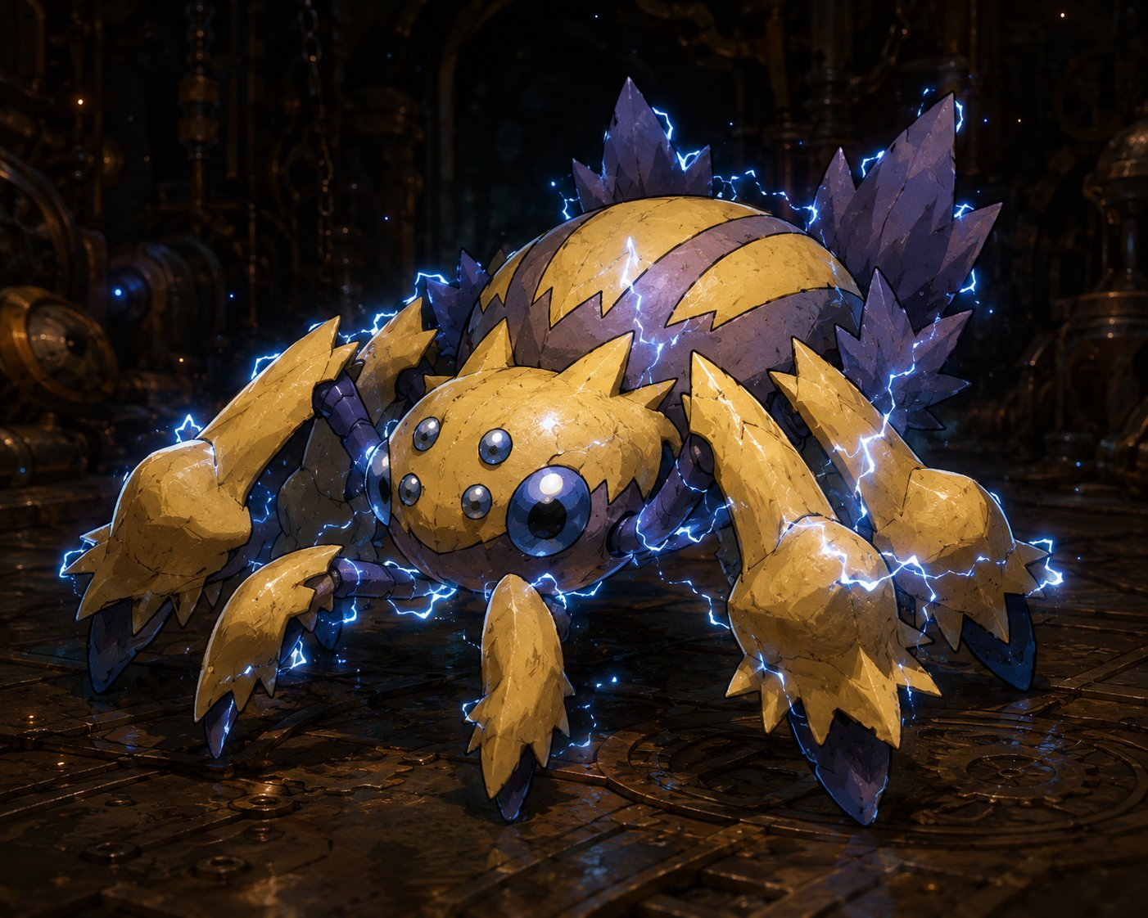  AC 15 HP 22 (5d6+5) Speed 30 ft, climb 30 ft Init +3  STR 7 DEX 17 CON 13 INT 5 WIS 10 CHA 6  Resist lightning  Senses darkvision 60 ft  Traits  Phase-Blink. At the start of its turn, roll d6: on a 1–2 it begins Unreal. While Unreal it resists all damage except force and radiant, and attacks against it have disadvantage — but it can’t be webbed or grappled, and must become Real to attack. (Tell the players — force & radiant are the counter.)  Static Cling. The first time it hits a creature each turn, that target’s lightning resistance is ignored and its allies have advantage on their next attack vs that target. (Punishes clumping near Skitch.)  Actions  Spark Bite. +5 to hit, reach 5 ft. Hit: 1d6+3 piercing + 1d6 lightning.  Arc (Recharge 5–6). 15-ft line, DC 13 Dex save, 2d8 lightning (half on save). Two+ Voltcrawlers within 15 ft can chain into one 3d8 line — use it to spike a clustered party. | VOLTCRAWLER BROODMOTHER  Medium aberration (planar intruder) • boss-adjacent pressure  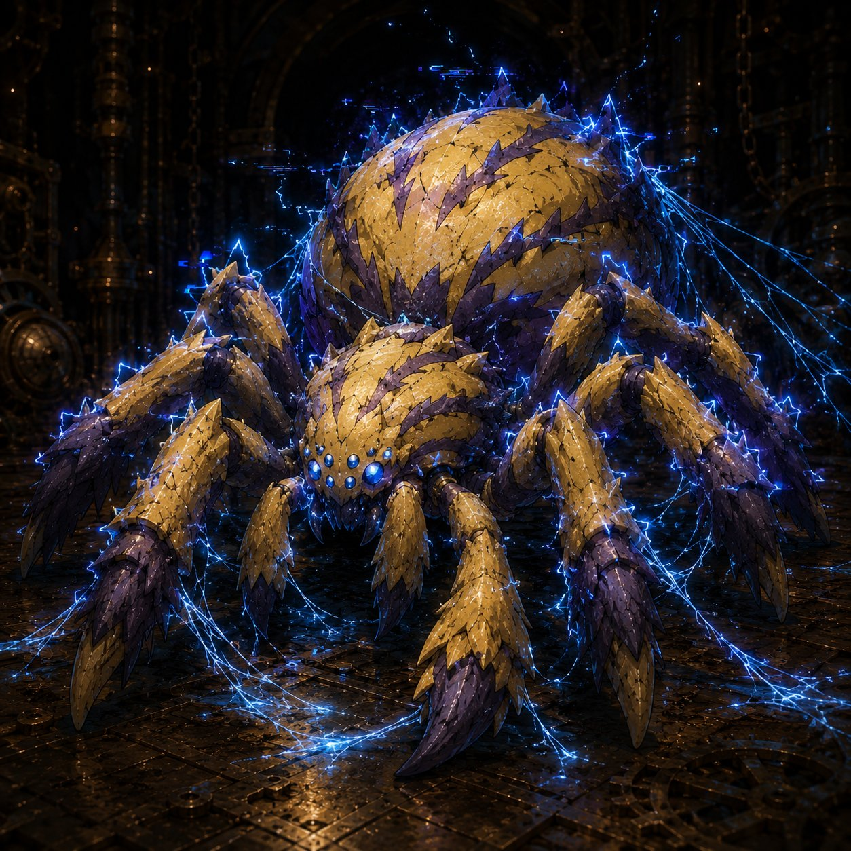  AC 16 HP 95 (10d8+50) Speed 40 ft, climb 40 ft Init +4  STR 14 DEX 18 CON 20 INT 6 WIS 12 CHA 8  Saves Dex +7, Con +8  Resist lightning; nonmagical B/P/S  Senses darkvision 60 ft  Traits  Phase-Blink (greater). Chooses to go Unreal as a free action once per round (no roll). Smart play: blink Unreal right after taking a big hit. Make them earn the kill.  Crackling Web. At the start of its turn, one creature it sees within 30 ft makes a DC 15 Dex save or is restrained by planar silk (action + DC 15 Str to break; web AC 12, 15 HP, immune lightning, VULNERABLE fire/cold — Lilly’s frost & Stabby’s cold katana cut it fast). Use turn 1 on Stabby or Ursa.  Actions  Multiattack. Two Lash attacks.  Lash. +7 to hit, reach 10 ft. Hit: 1d10+4 slashing + 1d8 lightning.  Overcharge (Recharge 6). 20-ft-radius burst, DC 15 Con save, 4d8 lightning (half). On a fail, the target also can’t take reactions until the end of its next turn (shuts off Lilly’s Shield & Stabby’s Deflect) — deploy when you want a hero to truly feel danger.
Tactics: Skitch is the objective — the Voltcrawlers swarm toward the pinned goblin, forcing the party to hold a fixed spot instead of kiting. The Broodmother opens with Crackling Web on Stabby or Ursa to kill their mobility, then anchors the room with Lash and Overcharge. The little ones blink Unreal to dodge — only force and radiant reliably land, so reward the table for figuring it out (Lilly’s Force Ballista, Ursa’s Guiding Bolt/Moonbeam). Bunch up near Skitch and the chained Arcs hurt. Let a hero drop to 0 if the dice say so — the choice of saving the hero or saving Skitch is the heart of the fight.
(Running Enemies page — Fight 1’s Rogue Servitor and Cargo Hauler are on the Beat 2 sheet; the Iron Drudge and the Grand Custodian boss join this page in Beats 5 and 6.)

